**[Find if Path Exists in Graph](https://leetcode.com/problems/find-if-path-exists-in-graph/description/)**

There is a **bi-directional** graph with n vertices, where each vertex is labeled from 0 to n - 1 (**inclusive**). The edges in the graph are represented as a 2D integer array edges, where each edges[i] = [ui, vi] denotes a bi-directional edge between vertex ui and vertex vi. Every vertex pair is connected by **at most one** edge, and no vertex has an edge to itself.

You want to determine if there is a **valid path** that exists from vertex source to vertex destination.

Given edges and the integers n, source, and destination, return true*if there is a****valid path****from*source*to*destination*, or*false*otherwise.*

**Example 1:**

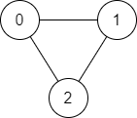

**Input:** n = 3, edges = [[0,1],[1,2],[2,0]], source = 0, destination = 2

**Output:** true

**Explanation:** There are two paths from vertex 0 to vertex 2:

- 0 → 1 → 2

- 0 → 2

**Example 2:**

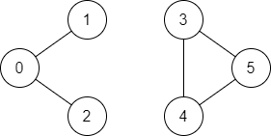

**Input:** n = 6, edges = [[0,1],[0,2],[3,5],[5,4],[4,3]], source = 0, destination = 5

**Output:** false

**Explanation:** There is no path from vertex 0 to vertex 5.

**Constraints:**

* 1 <= n <= 2 * 105
* 0 <= edges.length <= 2 * 105
* edges[i].length == 2
* 0 <= ui, vi <= n - 1
* ui != vi
* 0 <= source, destination <= n - 1
* There are no duplicate edges.
* There are no self edges.